Career Progression and Promotion Gap Analysis for Retention Optimization at Palo Alto Networks

SOWMIYA N

|Data Science Intern |

|Unified Mentor June 2026|

Abstract
Employee retention remains one of the most critical challenges in modern workforce management. While many organizations invest heavily in attrition prediction systems, traditional approaches primarily focus on identifying employees who are likely to leave rather than understanding the underlying causes of disengagement. Research has shown that employees often exit organizations due to limited career advancement opportunities, prolonged periods without promotion, stagnation within the same role, inadequate skill development, and inconsistent managerial support.
This study introduces a Career Progression and Promotion Gap Analysis framework designed to identify structural career-growth barriers before they result in employee turnover. Using employee demographic, performance, promotion, training, and managerial history data, the project applies feature engineering, clustering analysis, promotion-gap risk scoring, and retention-opportunity identification techniques to uncover hidden workforce patterns.
The proposed framework enables Palo Alto Networks to move from reactive attrition management toward proactive career-centric retention planning. Results provide actionable insights for leadership regarding promotion policies, training investment, managerial continuity, and employee development pathways.
Keywords: Employee Retention, Career Analytics, Promotion Gap Analysis, Workforce Intelligence, Human Resource Analytics, K-Means Clustering, Career Stagnation, Talent Management
1. Introduction
Organizations operating in highly competitive technology sectors face increasing challenges in retaining skilled employees. Traditional retention programs often rely on employee satisfaction surveys, compensation adjustments, or reactive interventions after disengagement has already occurred.
However, employee departure decisions frequently emerge from long-term career concerns rather than immediate dissatisfaction. Employees who experience prolonged promotion delays, limited role mobility, insufficient learning opportunities, or inconsistent managerial relationships may gradually disengage despite maintaining satisfactory performance levels.
Palo Alto Networks operates in an industry characterized by rapid innovation, evolving skill requirements, and intense competition for cybersecurity talent. Therefore, understanding employee career progression patterns becomes essential for sustaining workforce stability and organizational performance.
This research proposes a data-driven framework that examines employee career trajectories and promotion histories to identify hidden retention opportunities. Unlike conventional attrition prediction models, the focus is not on determining who will leave but on understanding why employees may eventually become vulnerable to departure.

2. Background and Context
Employee retention has traditionally been approached through attrition prediction models that estimate the probability of employee departure. While such models provide valuable risk assessments, they frequently fail to explain the organizational factors contributing to disengagement.
Several workforce studies have identified the following drivers of voluntary turnover:
- Promotion stagnation
- Career plateauing
- Limited training participation
- Weak managerial continuity
- Reduced role mobility
- Lack of developmental opportunities
Organizations that identify these factors early can intervene through targeted development programs, promotion reviews, mentoring initiatives, and role rotations.
The concept of Career Trajectory Intelligence expands workforce analytics beyond attrition prediction by analyzing employee progression patterns throughout their tenure.

3. Problem Statement
Palo Alto Networks currently lacks:
- A comprehensive view of employee career progression patterns
- Early identification of promotion stagnation
- Objective promotion-gap measurement
- Career-centric retention opportunity detection
Consequently, retention efforts may become generic rather than personalized to individual career-development needs.
Without proactive career analytics:
- Promotion delays remain undetected
- Career stagnation accumulates over time
- Development opportunities are missed
- Valuable talent becomes increasingly susceptible to external opportunities

4. Research Objectives
Primary Objectives
- Identify employee career progression patterns.
- Measure promotion stagnation levels.
- Detect employees experiencing career-growth barriers.
- Develop retention opportunity indicators.
Secondary Objectives
- Analyze managerial continuity impacts.
- Evaluate training participation effectiveness.
- Create interpretable employee career clusters.
- Support data-driven talent-management decisions.
5. Dataset Description
The dataset contains employee demographic, compensation, performance, managerial, and career-development information.
Table 1: Employee Dataset Variables
Category | Variables
Demographics | Age, Gender, Marital Status
Compensation | Monthly Income, Daily Rate, Hourly Rate
Performance | Performance Rating, Job Involvement
Career Growth | Job Level, Years at Company, Years Since Last Promotion
Learning | TrainingTimesLastYear
Management | Years with Curr Manager
Satisfaction | Job Satisfaction, Work-Life Balance
Attrition | Attrition

6. Research Methodology
The project follows the CRISP-DM framework:
- Business Understanding
- Data Understanding
- Data Preparation
- Modeling
- Evaluation
- Deployment
Figure 1: Research Workflow
Data Collection → Data Cleaning → Feature Engineering → Clustering → Promotion Risk Scoring → Retention Opportunity Identification → Dashboard

7. Feature Engineering
To better capture career-development patterns, several derived variables are introduced.
7.1 Promotion Gap Ratio
Formula:
Promotion Gap Ratio = Years Since Last Promotion / Years At Company
Interpretation:
Higher values indicate longer promotion delays relative to tenure.
7.2 Role Stagnation Index
Role Stagnation Index = Years in Current Role / Years At Company
Interpretation:
Measure’s role mobility over time.
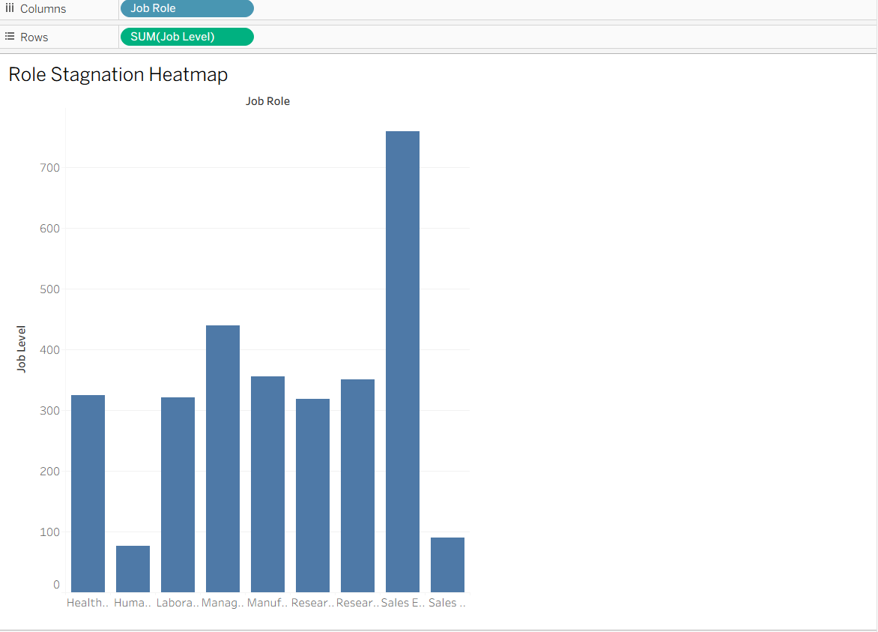
7.3 Training Intensity Score
Training Intensity Score = Training Times Last Year / Years At Company
Interpretation:
Captures investment in employee development.
7.4 Manager Stability Indicator
Manager Stability = Years with Curr Manager / Years At Company
Interpretation:
Evaluates leadership continuity throughout an employee’s tenure.
8. Data Preprocessing
Several preprocessing techniques are applied:
- Missing-value validation
- Outlier treatment
- Standardization of numerical variables
- One-hot encoding of categorical variables
- Feature scaling using Standard Scaler
The resulting dataset is optimized for clustering and workforce segmentation.
9. Career Path Clustering
Unsupervised learning techniques are applied to identify naturally occurring employee career patterns.
Primary Algorithm
K-Means Clustering
Validation Algorithm
Hierarchical Clustering
Expected clusters include:
Cluster A: Fast-Track Performers
Characteristics:
- Frequent promotions
- High training participation
- Strong performance
Cluster B: Stable Contributors
Characteristics:
- Consistent performance
- Moderate promotion progression
- Long organizational tenure
Cluster C: Promotion-Stalled Employees
Characteristics:
- Long promotion delays
- Limited role movement
- Elevated retention concern
Cluster D: Early-Career Explorers
Characteristics:
- Short tenure
- Active learning participation
- Developing career paths

10. Promotion Gap Risk Framework
A promotion-gap risk score is assigned to each employee.
Table 2: Risk Classification
Score | Risk Level
0–33 | Low
34–66 | Medium
67–100 | High
The score combines:
- Promotion Gap Ratio
- Role Stagnation Index
- Training Intensity Score
- Manager Stability Indicator
- Cluster Membership
11. Retention Opportunity Index
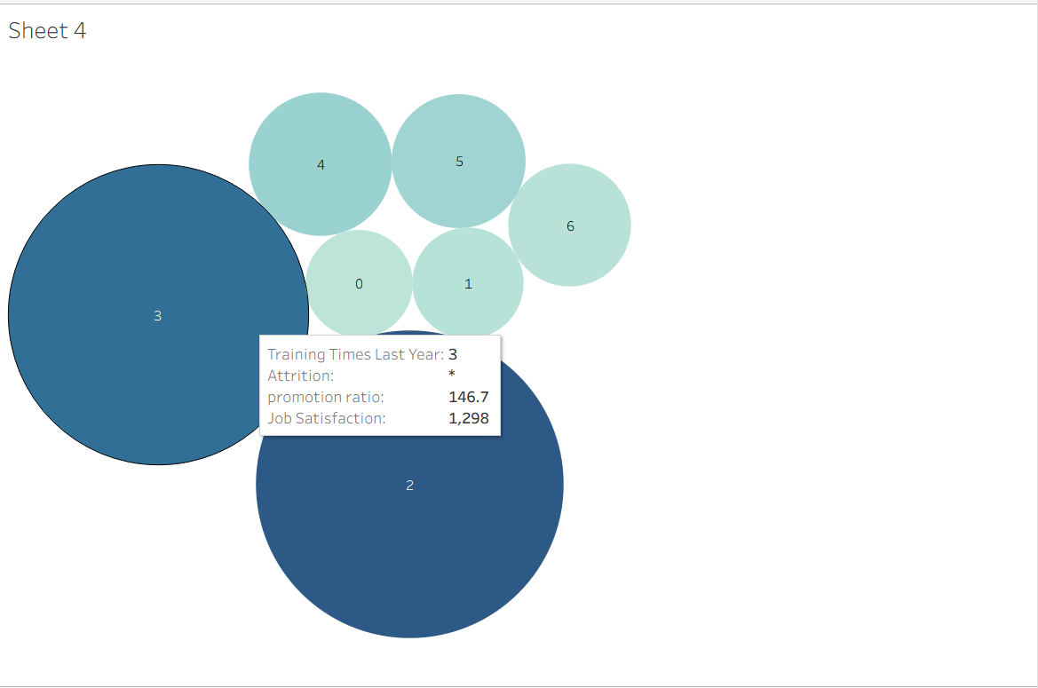
Job Satisfaction
4 | ●
3 | ●
2 | ●
1 | ●
+----------------------------
0.2 0.4 0.6 0.8 1.0
Promotion Gap Ratio
Unlike attrition prediction, this metric identifies employees who are:
- Still engaged
- Not yet at high attrition risk
- Showing early signs of career stagnation
These employees represent the highest return-on-investment intervention targets.
12. Dashboard Design
The Streamlit application contains four major modules:
Career Path Clustering Dashboard
- Cluster distribution
- Career-path visualization
- Cluster-level summaries
Promotion Gap Monitor
- High-gap employee identification
- Department-level promotion analysis
Retention Opportunity Panel
- Intervention candidate ranking
- Suggested career actions
Managerial Insight Dashboard
- Manager tenure analysis
- Team-level stagnation monitoring
13. Expected Business Impact
Implementation of the proposed framework is expected to:
- Improve retention strategy effectiveness
- Increase promotion transparency
- Enhance workforce planning
- Reduce voluntary turnover
- Strengthen employee development programs
14. Recommendations
- Conduct quarterly promotion-gap reviews.
- Expand employee training pathways.
- Implement structured career-roadmap discussions.
- Monitor manager continuity metrics.
- Prioritize intervention for high-risk stagnation clusters.

15. Conclusion
This research introduces a career-intelligence framework designed to identify promotion stagnation and retention opportunities before employees become disengaged. By combining feature engineering, clustering, risk scoring, and workforce analytics, the proposed solution provides a proactive approach to employee retention. The framework enables Palo Alto Networks to move beyond predicting attrition and toward understanding the structural career factors that influence long-term workforce stability.
References
- CRISP-DM Consortium. CRISP-DM 1.0 Step-by-Step Guide.
- Hair, J. F., Black, W. C., Babin, B. J., & Anderson, R. E. Multivariate Data Analysis.
- Jain, A. K. Data Clustering: 50 Years Beyond K-Means.
- SHRM Workforce Analytics Reports.
- IBM HR Analytics Employee Attrition Dataset Documentation.
- Cascio, W. F. Managing Human Resources.
- Dessler, G. Human Resource Management.
- Unified mentors

